PRESSURE
Pearson Edexcel - Thursday 7 June 2018 - Paper 2 (Calculator) Higher Tier
1.
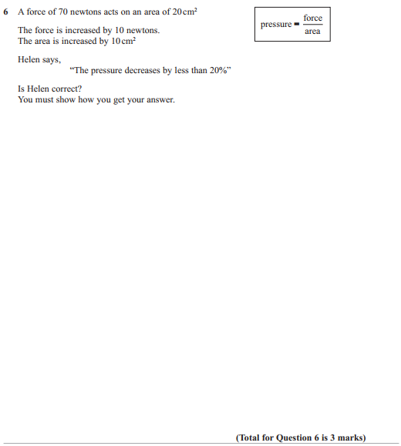

Pearson Edexcel - Specimen Papers Set 1 - Paper 1 (Non-Calculator) Higher Tier
2.
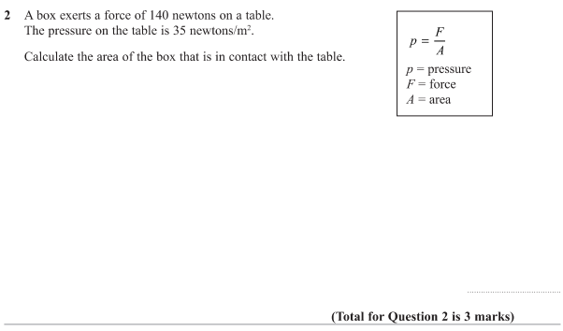
Pearson Edexcel - Sample Paper 1 - (Non-Calculator) Higher Tier
3.
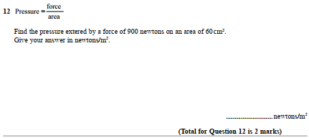
AQA GSCE – Thursday 6 November 2017 – Paper 2 (Calculator) Higher Tier
4.
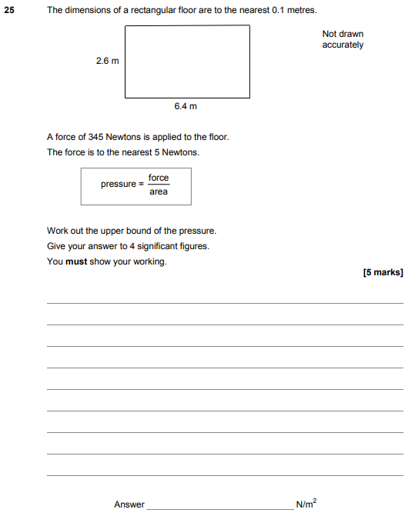
AQA GSCE – Sample Paper 3 (Calculator) Higher Tier
5.
